FIFO Page Replacement Algorithm
Write a C program to implement the FIFO Page Replacement Algorithm. The program should take the number of frames and a reference string (sequence of page requests) as input. For each page in the reference string, determine if it results in a 'Page Hit' or a 'Page Fault'. Display the state of the frames after each request and calculate the total number of page faults and hits.
Input Format
- The first line of input contains an integer representing the number of pages in the reference string.
- The second line contains the page reference string as a sequence of integers.
- The third line contains an integer representing the number of available frames.
Output Format
The total number of Page Faults and Page Hits are displayed
Sample Input 1
7
1 3 0 3 5 6 3
3
Sample Output 1
Enter number of pages in reference string:
Enter the reference string:
Enter number of frames:
Total Page Faults: 6
Total Page Hits: 1
How it works
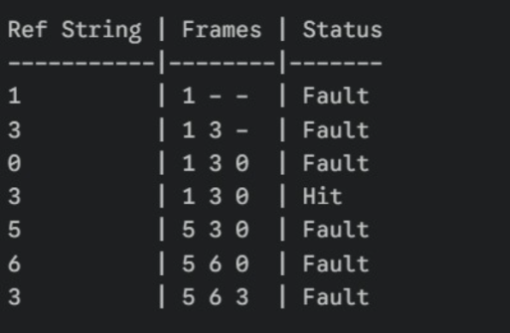
CODE:

#include <stdio.h>

int main() {

int n, frames;

printf("Enter number of pages in reference string: \n");
scanf("%d", &n);

int ref[n];

printf("Enter the reference string: \n");

for(int i = 0; i < n; i++) {
scanf("%d", &ref[i]);
}

printf("Enter number of frames: \n");
scanf("%d", &frames);

int frame[frames];

for(int i = 0; i < frames; i++) {
frame[i] = -1;
}

int front = 0;
int faults = 0;
int hits = 0;

for(int i = 0; i < n; i++) {

int found = 0;

for(int j = 0; j < frames; j++) {

if(frame[j] == ref[i]) {

found = 1;
hits++;
break;
}
}

if(!found) {

frame[front] = ref[i];
front = (front + 1) % frames;

faults++;
}

}

printf("\nTotal Page Faults: %d\n", faults);
printf("Total Page Hits: %d\n", hits);

return 0;

}

RESULT:

